19th Sunday in Ordinary Time
First Reading: 1 Kings 19:9, 11-13
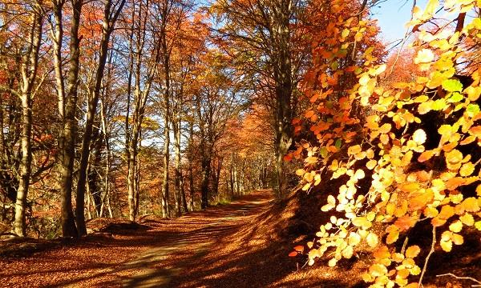
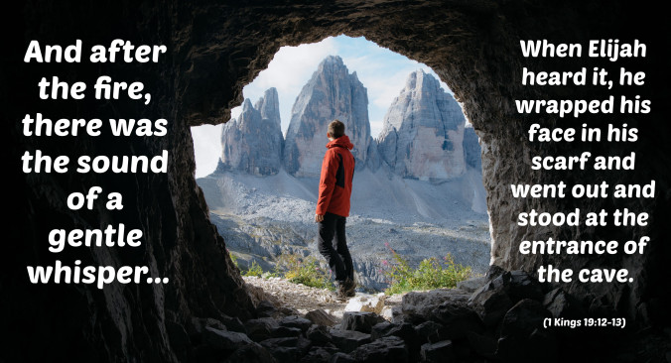
God’s voice was like the gentle whisper of a breeze
At that place Elijah came to a cave, and spent the night there. Then the word of the Lord came to him, saying, “What are you doing here, Elijah?” He said, “Go out and stand on the mountain before the Lord, for the Lord is about to pass by. ” Now there was a great wind, so strong that it was splitting mountains and breaking rocks in pieces before the Lord, but the Lord was not in the wind; and after the wind an earthquake, but the Lord was not in the earthquake; and after the earthquake a fire, but the Lord was not in the fire; and after the fire a sound of sheer silence. When Elijah heard it, he wrapped his face in his mantle and went out and stood at the entrance of the cave.

Responsorial: Psalm 84:9-14
Response: Lord, show us your mercy and love, and grant us your salvation.
I will hear what the Lord God has to say,
a voice that speaks of peace.
His help is near for those who fear him
and his glory will dwell in our land. Resp:
Mercy and faithfulness have met;
justice and peace have embraced.
Faithfulness shall spring from the earth
and justice look down from heaven. Resp:
The Lord will make us prosper
and our earth shall yield its fruit.
Justice shall march before him
and peace shall follow his steps. Resp:
Second Reading: Romans 9:1-5

Paul grieves at the Jews’ refusal to accept Jesus. He would do anything to win them for Christ

I am speaking the truth in Christ-I am not lying; my conscience confirms it by the Holy Spirit- I have great sorrow and unceasing anguish in my heart. For I could wish that I myself were accursed and cut off from Christ for the sake of my own people, my kindred according to the flesh. They are Israelites, and to them belong the adoption, the glory, the covenants, the giving of the law, the worship, and the promises; to them belong the patriarchs, and from them, according to the flesh, comes the Messiah, who is over all, God blessed forever. Amen.

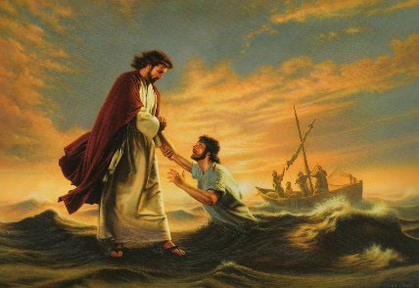
Gospel Acclamation:
Alleluia, Alleluia !
I hope in the Lord,
I trust in his word.
Alleluia !

Gospel: Matthew 14:23-33
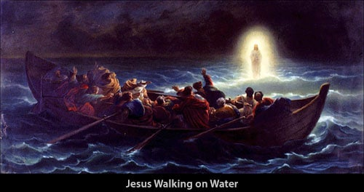

When Peter begins to sink Jesus chides him for his lack of faith
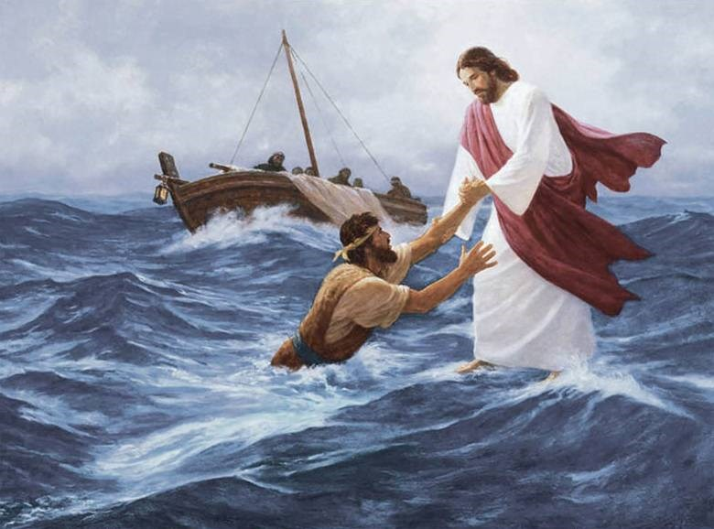
Jesus made the disciples get into the boat and go on ahead to the other side, while he dismissed the crowds. And after he had dismissed the crowds, he went up the mountain by himself to pray. When evening came, he was there alone, but by this time the boat, battered by the waves, was far from the land, for the wind was against them. And early in the morning he came walking toward them on the sea. But when the disciples saw him walking on the sea, they were terrified, saying, “It is a ghost!” And they cried out in fear.
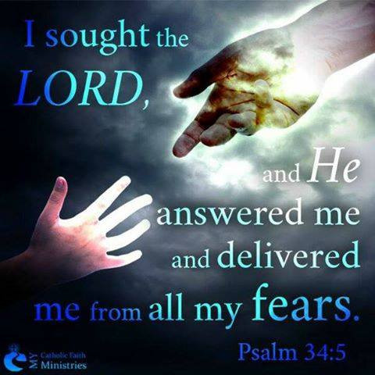
Immediately Jesus spoke to them and said, “Take heart, it is I; do not be afraid. ” Peter answered him, “Lord, if it is you, command me to come to you on the water. ” He said, “Come. ” So Peter got out of the boat, started walking on the water, and came toward Jesus. But when he noticed the strong wind, he became frightened, and beginning to sink, he cried out, “Lord, save me!” Jesus immediately reached out his hand and caught him, saying to him, “You of little faith, why did you doubt?” When they got into the boat, the wind ceased. And those in the boat worshiped him, saying, “Truly you are the Son of God.”

REFLECTIONS:
Based on the passage of St Matthew’s Gospel this Sunday we have just read, we can see that our life, in one way or another, is considered as a combination of many stages which we might have experienced. Reflecting on some of these stages, we can discover a lot of things that we haven’t got time to think of. Here are some stages of life we can reflect, think and re-discover:
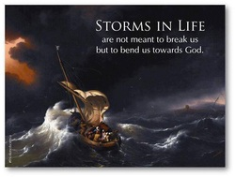
1. Voyage: Life can be viewed as journey or still better as voyage. We sail upon a rippling surface of events, feeling the joy of movement, being alive and going somewhere. When things go well, we feel the contentment of those experienced sailors, the apostles on their way home across the quiet lake of Galilee. When things go against our will, we feel sad and disappointed. We complain and sometimes, we lose our trust in others or even our faith in God.
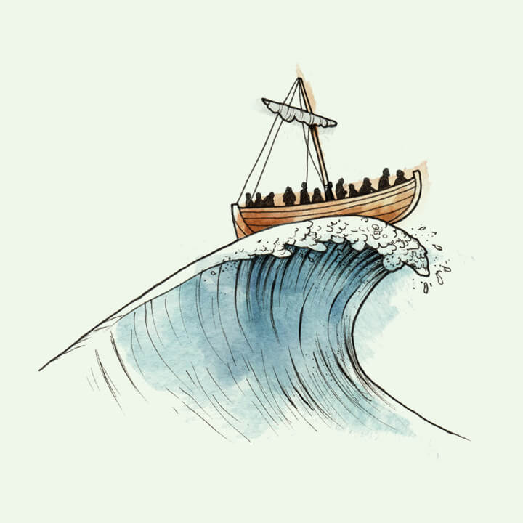
2. Waves: A gale blew up, changing their mood. Danger and fear of drowning. Our own life - voyage has its share of storms too, anxieties, problems and pressures of various kinds. How often a sudden turn of events can rob us of inner peace. Are we on a charted course, or just drifting along without any determined direction? Many find it hard enough to stay afloat, pressurised by the bewilderingly changing times, ill-at-ease in their relationships with others, discontented and insecure in themselves. That’s exactly what the frightened apostles in the storm mean for us today: we are those sailors, tossing about in the waves.
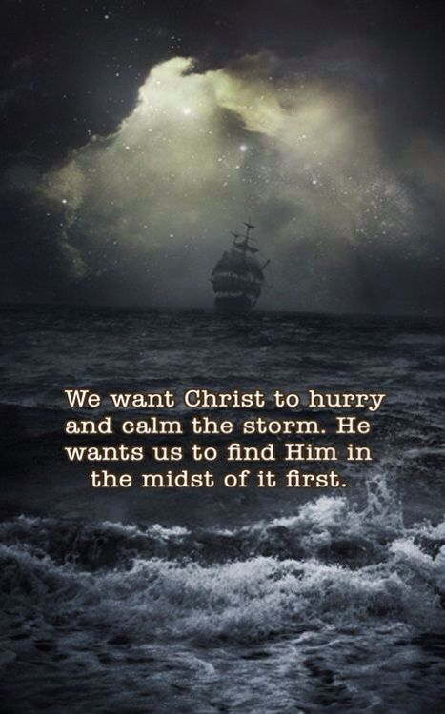
3. Remedies: Many prescriptions are suggested, to ease the upsets of our voyage. Like different brands of medication for sea-sickness! A long quiet rest, a change of occupation, psychiatric help or counselling, a course of Yoga or Transcendental Meditation, Contemplative or Charismatic Prayer. Doubtless, every remedy has its own advantages, but what better support can be found in times of stress than an understanding friend? Today’s Gospel suggests that our first and most constant recourse should be to none other than, Christ himself.
4. Presence: God is present where we least expect him, although it is a hidden, unseen presence, not always easy to discover. It takes faith nearer than the door.” So the apostles were amazed to see Christ coming to them in the middle of the storm, for (at that stage) they were men of little faith. Elijah, that lonely refugee, faithful to his God despite cruel persecution by Jezebel, discovered the mysterious presence of God in the still, small voice of his own soul. Standing at the mouth of a cave, on the slopes of the holy mountain, he got strength and comfort from the Living God. Where God is, there is peace. But his presence is everywhere, for those who learn to discern it.

In his poem, The Kingdom of God, Francis Thompson expresses his belief in God’s unseen presence:
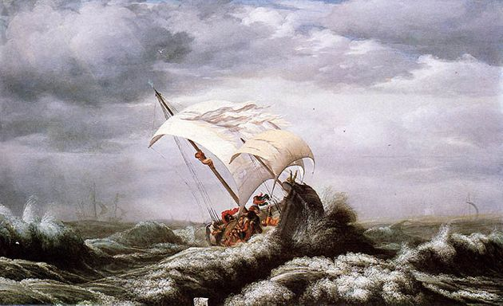
O world invisible, we view thee,
O world intangible, we touch thee,
O world unknowable, we know thee,
Inapprehensible, we clutch thee!
Does the fish soar to find the ocean,
The eagle plunge to find the air —
That we ask of the stars in motion
If they have rumour of thee there?
Not where the wheeling systems darken,
And our benumbed conceiving soars!
The drift of pinions, would we hearken,
Beats at our own clay-shuttered doors.
The angels keep their ancient places;-
Turn but a stone, and start a wing!
‘Tis ye, ’tis your estranged faces,
That miss the many-splendoured thing.
But when so sad thou canst not sadder
Cry; — and upon thy so sore loss
Shall shine the traffic of Jacob’s ladder
Pitched betwixt Heaven and Charing Cross.
Yea, in the night, my Soul, my daughter,
Cry, — clinging Heaven by the hems;
And lo, Christ walking on the water
Not of Gennesareth, but Thames!
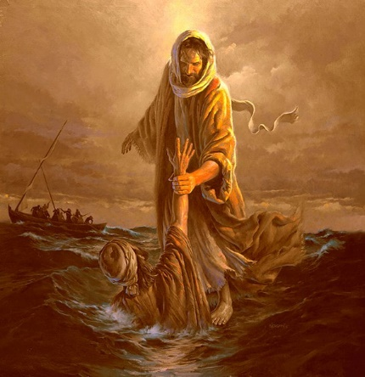
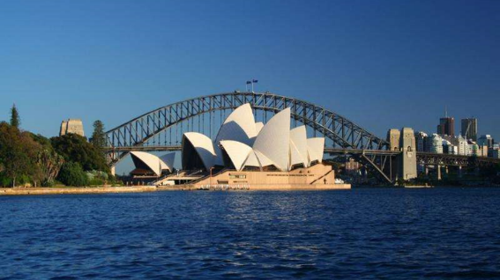
5. Safe Harbour: We do not expect to be immune from the hardships and problems faced by all the other voyagers through this life. Indeed, Christ himself shared fully in all of these anxieties, being tested as we are. If the Church be seen as a boat (in which there are no idle passengers, but all are needed to row!), then we have as destination the safe harbour of eternal life. With the compass of faith, and Christ himself as unseen captain of the ship, that harbour will surely be reached. In the meantime, though tossed about by circumstances, he tells us: “Courage! Do not be afraid, men of little faith!’
